WEEKLY ASSESSMENT – 1

FOUNDATION & LOGIC DESIGN

Name: PENUKULA ASHWIN RUDRAKSH

Assessment Objective
The objective of this assessment is to understand basic digital logic gates, truth tables and binary parity through circuit simulation and C programming. The work is divided into two parts: a combinational logic circuit (Q1.1) and a 4-bit binary parity program (Q1.2).
Note about practical evidence: This document provides the circuit design, wiring plan, expected truth-table results and exact steps for testing in Tinkercad. I cannot sign in to or operate the student's Tinkercad account from this chat. Therefore, the tables below are theoretical expected results, not claimed screenshots or measurements from a completed live simulation. After building the circuit, insert your own Tinkercad screenshots and confirm the observed outputs.

Q1.1 – Combinational Logic Circuit

1. Introduction
A combinational logic circuit is a digital circuit whose output depends only on the present input values. It does not store previous input states. Logic gates are the basic building blocks used to make these circuits.

2. Logic gates used
Gate | Operation | Output rule | Boolean expression
AND | Logical multiplication | Output is 1 only when both inputs are 1. | Y = A · B
OR | Logical addition | Output is 1 when at least one input is 1. | Y = A + B
NOT | Inversion | Output is the opposite of the input. | Y = A̅

For this assignment, the three gates are connected to form one example combinational circuit. Since the assessment brief names the gates but does not prescribe a single Boolean expression, the following clearly stated design is used:
F = (A · B) + C̅
The AND gate receives A and B. The NOT gate receives C. The outputs of the AND and NOT gates are connected to the two inputs of the OR gate. The OR gate gives the final output F.
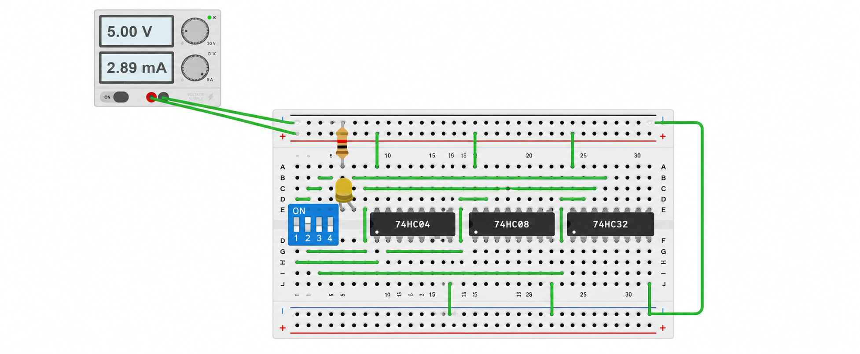

3. Individual gate truth tables
A | B | AND output A·B | OR output A+B
0 | 0 | 0 | 0
0 | 1 | 0 | 1
1 | 0 | 0 | 1
1 | 1 | 1 | 1

Input C | NOT output C̅
0 | 1
1 | 0

4. Combined circuit truth table
A | B | C | A·B | C̅ | F = (A·B)+C̅
0 | 0 | 0 | 0 | 1 | 1
0 | 0 | 1 | 0 | 0 | 0
0 | 1 | 0 | 0 | 1 | 1
0 | 1 | 1 | 0 | 0 | 0
1 | 0 | 0 | 0 | 1 | 1
1 | 0 | 1 | 0 | 0 | 0
1 | 1 | 0 | 1 | 1 | 1
1 | 1 | 1 | 1 | 0 | 1

Reading the table: when A=0, B=0 and C=0, the NOT gate produces 1, so the OR gate output is 1. When A=1, B=1 and C=1, the AND gate produces 1 and the NOT gate produces 0, so the final output is also 1. The output is 0 only when A·B=0 and C̅=0; this occurs when C=1 and A and B are not both 1.

5. Tinkercad circuit construction
Open Tinkercad Circuits and create a new circuit. Use the available digital logic IC components if they are present in the component panel. A common 5 V logic-IC arrangement is shown below; check the exact component labels and pinout displayed in Tinkercad before wiring.
- Open https://www.tinkercad.com/ and sign in. Select Circuits, then choose Create new Circuit.
- Add three input controls. You can use three slide switches or toggle switches and label them A, B and C. Provide a clear LOW (0) and HIGH (1) state for each input.
- Add an AND IC (for example, 74HC08), an OR IC (for example, 74HC32), and a NOT IC (for example, 74HC04), if these parts are available in the Tinkercad component list.
- Connect the power pins of each IC according to its datasheet/component pinout. For the common 14-pin 74HC versions, pin 14 is VCC and pin 7 is GND. Connect VCC to +5 V and GND to ground. Do not leave the IC power pins unconnected.
- Connect switch A and switch B to the two inputs of one AND gate. Connect the AND output to one input of the OR gate.
- Connect switch C to one input of a NOT gate. Connect the NOT output to the other input of the OR gate.
- Connect the OR output to an LED through a suitable current-limiting resistor, or to a logic probe/logic indicator. The indicator represents output F.
- Make sure every input has a defined LOW or HIGH state. Avoid leaving logic inputs floating. Use pull-down or pull-up resistors if required by the switch wiring.
- Start Simulation. Change A, B and C through all eight combinations. Record the indicator state for each combination and compare it with the combined truth table above.
- Stop the simulation after testing. Capture a screenshot showing the complete circuit and, if possible, screenshots of representative input combinations.

6. Suggested wiring/pin planning
Signal | Connection
A | Switch A → first input of AND gate
B | Switch B → second input of AND gate
AND output | AND output → first input of OR gate
C | Switch C → input of NOT gate
NOT output | NOT output → second input of OR gate
F | OR output → LED + series resistor / logic indicator
Power | Each logic IC VCC → +5 V; GND → common ground

Important: IC pin numbers for the selected gate package must be checked against the component pinout. The signal plan above is the required logical connection; use the actual pin labels shown by the simulator rather than guessing pin positions.

7. Testing and verification record
Use this table while running the Tinkercad simulation. The expected output is already calculated. Fill in the observed output only after testing the circuit.

A | B | C | Expected F | Observed F (fill after test)
0 | 0 | 0 | 1 | 1
0 | 0 | 1 | 0 | 0
0 | 1 | 0 | 1 | 1
0 | 1 | 1 | 0 | 0
1 | 0 | 0 | 1 | 1
1 | 0 | 1 | 0 | 0
1 | 1 | 0 | 1 | 1
1 | 1 | 1 | 1 | 1

Verification rule: the circuit passes a test row when the observed output is the same as the expected output. All eight rows should match before concluding that the circuit is verified.

8. Observation and result
Expected observation: the AND gate becomes HIGH only when A and B are both HIGH. The NOT gate gives the opposite of C. The OR gate gives HIGH if either of its inputs is HIGH. Therefore, the final output follows F = (A·B)+C̅.
Result: The Boolean design and theoretical truth table for a circuit using AND, OR and NOT gates have been prepared. The practical result must be confirmed by running the circuit in Tinkercad and completing the observed-output column.

Q1.2 – 4-Bit Binary Parity Program

1. Introduction to parity
Parity is a simple method used in digital systems to check whether binary data may contain an error. It is based on counting the number of binary 1s in a data group.
- Even parity: the number of 1s in the 4-bit input is even (0, 2 or 4).
- Odd parity: the number of 1s in the 4-bit input is odd (1 or 3).
This program classifies the four input bits themselves. It does not add an extra parity bit.

2. Truth table for all 4-bit inputs
4-bit input | Number of 1s | Parity
0000 | 0 | Even
0001 | 1 | Odd
0010 | 1 | Odd
0011 | 2 | Even
0100 | 1 | Odd
0101 | 2 | Even
0110 | 2 | Even
0111 | 3 | Odd
1000 | 1 | Odd
1001 | 2 | Even
1010 | 2 | Even
1011 | 3 | Odd
1100 | 2 | Even
1101 | 3 | Odd
1110 | 3 | Odd
1111 | 4 | Even

3. Algorithm
- Start the program.
- Read four binary digits from the user.
- Check that the input contains exactly four characters and every character is either 0 or 1.
- Count the number of 1s in the four bits.
- If the count is divisible by 2, display Even parity.
- Otherwise, display Odd parity.
- Stop.

4. C source code
#include <stdio.h>
#include <string.h>
int main(void)
{
char bits[100];
int count = 0;
int i;
printf("Enter a 4-bit binary number: ");
if (scanf("%99s", bits) != 1) {
printf("Input error.\\n");
return 1;
}
if (strlen(bits) != 4) {
printf("Invalid input. Enter exactly 4 bits.\\n");
return 1;
}
for (i = 0; i < 4; i++) {
if (bits[i] == '1') {
count++;
} else if (bits[i] != '0') {
printf("Invalid input. Use only 0 and 1.\\n");
return 1;
}
}
printf("Number of 1s = %d\\n", count);
if (count % 2 == 0) {
printf("The 4-bit input has EVEN parity.\\n");
} else {
printf("The 4-bit input has ODD parity.\\n");
}
return 0;
}

5. Explanation of the program
Statement / concept | Explanation
char bits[5] | Stores four binary characters and the string-ending character.
scanf("%4s", bits) | Reads up to four characters from the keyboard.
strlen(bits) | Checks the number of characters entered.
for loop | Checks each of the four positions.
if (bits[i] == '1') | Increases the count when the current bit is 1.
else if (bits[i] != '0') | Rejects characters other than 0 and 1.
count % 2 == 0 | Checks whether the number of 1s is even.
printf() | Displays the count and parity result.

The program uses conditional statements (if and else if) and a loop to examine the four bits. The modulus operator (%) gives the remainder after division. A remainder of zero when dividing the count by two means the count is even.

6. Sample program runs
Input: 0000
Number of 1s = 0
The 4-bit input has EVEN parity.
Input: 1010
Number of 1s = 2
The 4-bit input has EVEN parity.
Input: 1110
Number of 1s = 3
The 4-bit input has ODD parity.
Input: 1001
Number of 1s = 2
The 4-bit input has EVEN parity.
Input: 0001
Number of 1s = 1
The 4-bit input has ODD parity.

7. Program testing and verification
The expected classifications for all 16 possible inputs are listed in the truth table. Compile and run the C program using a C compiler or an online C environment. Enter each test value and compare the displayed parity with the table. Record actual test evidence or screenshots if required by the instructor.
Test input | Expected parity | Program result (fill after run)
0000 | Even | Even
0001 | Odd | Odd
0010 | Odd | Odd
0011 | Even | Even
0100 | Odd | Odd
0101 | Even | Even
0110 | Even | Even
0111 | Odd | Odd
1000 | Odd | Odd
1001 | Even | Even
1010 | Even | Even
1011 | Odd | Odd
1100 | Even | Even
1101 | Odd | Odd
1110 | Odd | Odd
1111 | Even | Even

8. Result
The C program counts the number of 1s in a 4-bit binary input. It displays EVEN parity when the count is 0, 2 or 4, and ODD parity when the count is 1 or 3. The truth table covers all 16 possible 4-bit combinations.

Overall Conclusion
This assessment explains how AND, OR and NOT gates can be combined to form a combinational logic circuit and how truth tables are used to predict its output. It also demonstrates the idea of even and odd parity through a C program that checks all four input bits. The theoretical results provide a basis for practical verification in Tinkercad and by running the C program.

